## Declaration

I, Wilson Wong, declare that this assignment, titled ITO5032, is my own original work and has not been copied from any other source except where explicitly acknowledged. I have not engaged in plagiarism, collusion, or any other form of academic misconduct in the preparation and submission of this assignment. All sources of information and data used in this assignment have been properly cited and referenced in accordance with the prescribed guidelines. I have not used unauthorized assistance in the preparation of this assignment and have not allowed any other student to copy my work. I am aware that any breach of academic integrity may result in disciplinary action as per the [policies of Monash University](https://www.monash.edu/learning-teaching/priorities-and-programs/assessment-and-academic-integrity/assessments-and-integrity-policy-and-procedure), which may include failing this assignment or the course, and further academic penalties.

Signature: W.W Date: 16/03/2025

## GitHub Check

Enter your GitHub details here.

|  |  |
| --- | --- |
| GitHub Username  *Enter your username here* | WilsonJWong |
| **A3 GitHub repository**  *Have you started and shared your assignment repository with your tutor yet?* | Yes |

## Self-Evaluation

Rate your performance for each criterion. Put a ✅(tick) in the box where you think your work belongs.

|  |  |  |  |  |
| --- | --- | --- | --- | --- |
| **Criteria** | **Exceeds Expectations** | **Meets Expectations** | **Needs Improvement** | **Fail to meet expectations** |
| Executive Summary | ✅ |  |  |  |
| User Personas | ✅ |  |  |  |
| Sitemap | ✅ |  |  |  |
| Wireframes/Low-fidelity Prototype | ✅ |  |  |  |

## 

## Section 1: Executive Summary

The Asylum Seeker Refugee Centre (ASRC) is the largest independent, non-profit charity organisation in Australia dedicated to supporting asylum seekers and refugees. ASRC provides essential resources for such people including food, shelter, healthcare, and general supplies. They also offering legal aid, community support, and educational services. As part of their mission to sustain and strengthen the physical, mental, and social wellbeing of asylum seekers / refugees, ASRC aims to expand its digital presence through the development of a modern web application, improving service accessibility.

By offering an online platform, ASRC can provide faster and more accessible aid, enabling more precise tailoring of support services to an individual’s needs. This digital transformation will enhance the organisation’s ability to assess asylum seekers’ situational requirements and connect them with the right resources for assistance in obtaining refugee status. Additionally, the platform will further assist refugees in adapting to their new environment by offering information and community driven support to ease their transition. The web application will function as a centralised platform to streamline support services, ensuring that both asylum seekers and refugees can access crucial aid when needed.

The development of this web application is guided by three core principles of user centric design, clear navigation, and intuitive usability. To ensure a smooth user experience, this website will be segregated into four distinct sections which are aligned to ASRC’s core operating objectives.

The landing page will follow a minimalist design approach and offers a high-level introduction to ASRC, its mission, services, and available resources. The community section will foster engagement through community-based discussion forums and local social initiatives, providing a space for users to connect and share experiences. The publications section will grant access to reports, legal guidelines, and informative articles, equipping users with the knowledge to understand their rights and options. Lastly, the resources section will serve as a comprehensive directory of services, connecting users with industry professionals for support and employment related tools.

Beyond these core sections, the website will also include dedicated areas for user login / registration, donations, and ASRC contact points. These additional features further enhance accessibility, support, and community engagement.

Through the implementation of a well-structured and intuitive web platform, ASRC aims to increase its ability to support both asylum seekers and refugees, fostering a more inclusive and accessible pathway toward stability and integration.

## Section 2: User Personas

Persona 1: Farida Khan

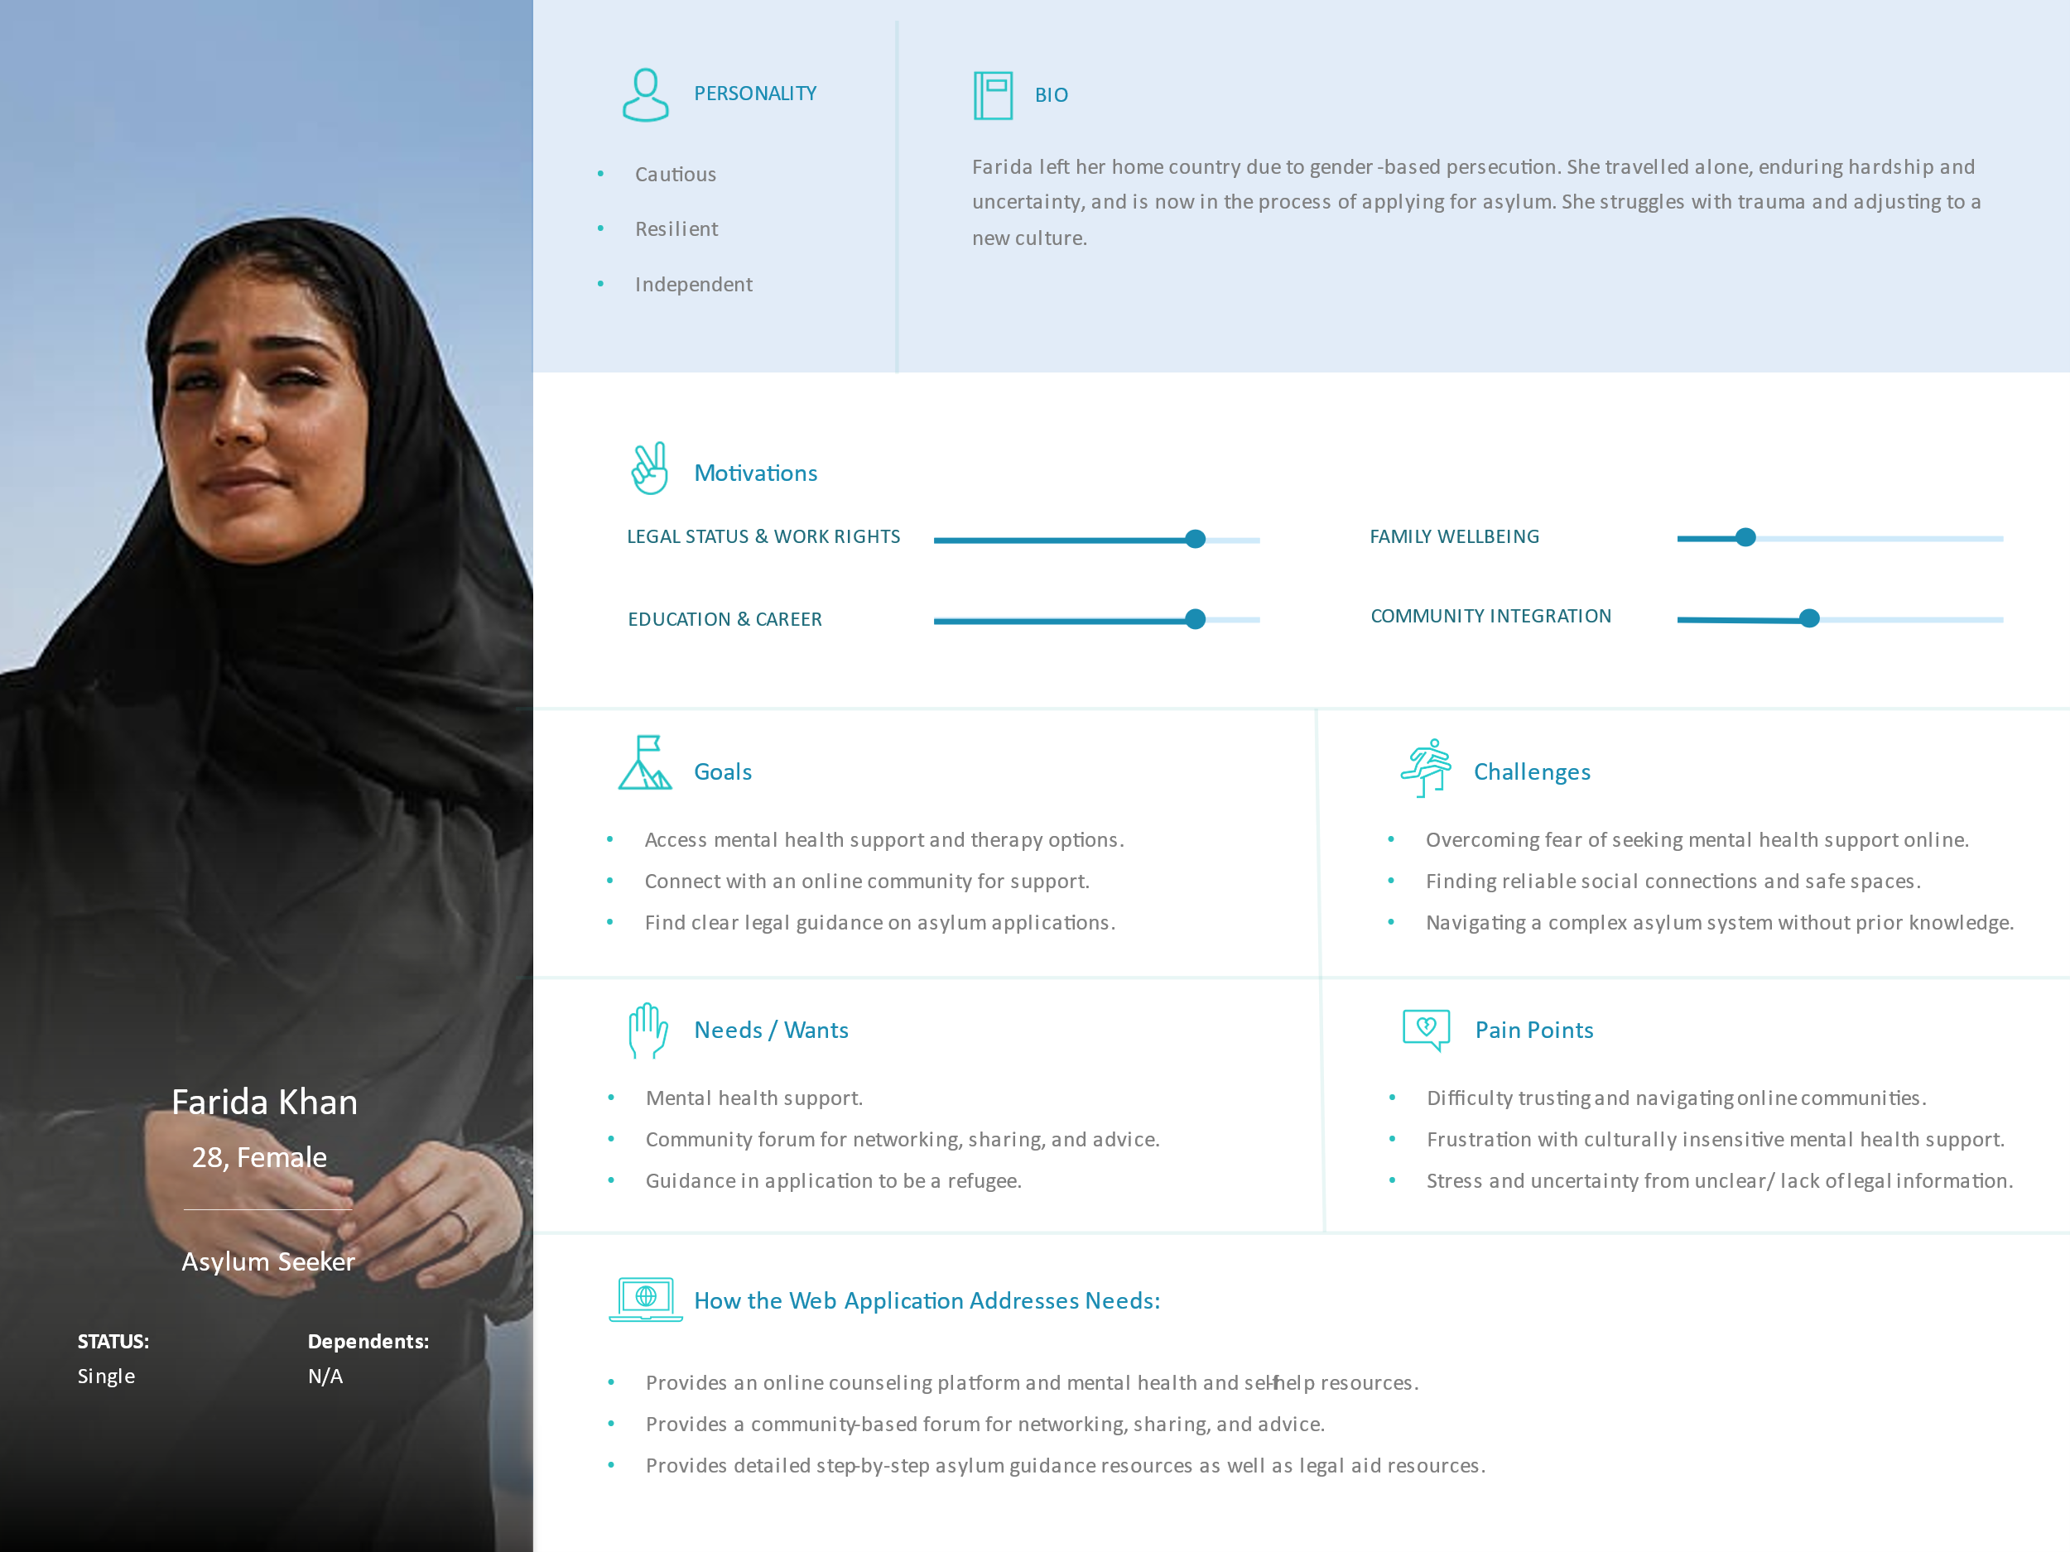

Persona 2: Omar Dabo

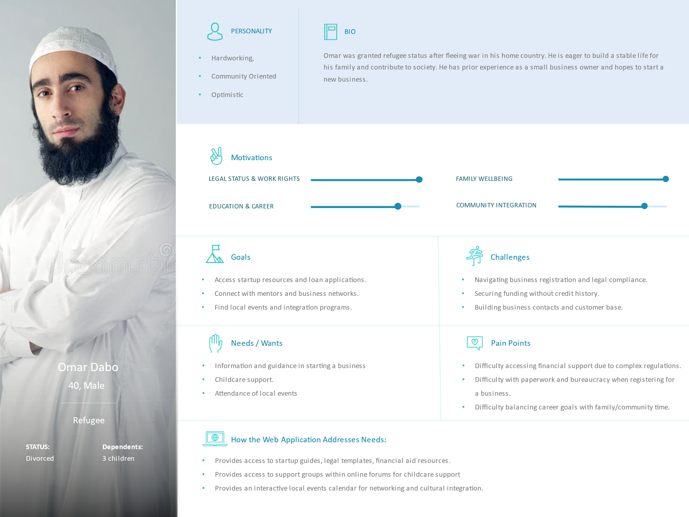

Persona 3: Amina Yusuf

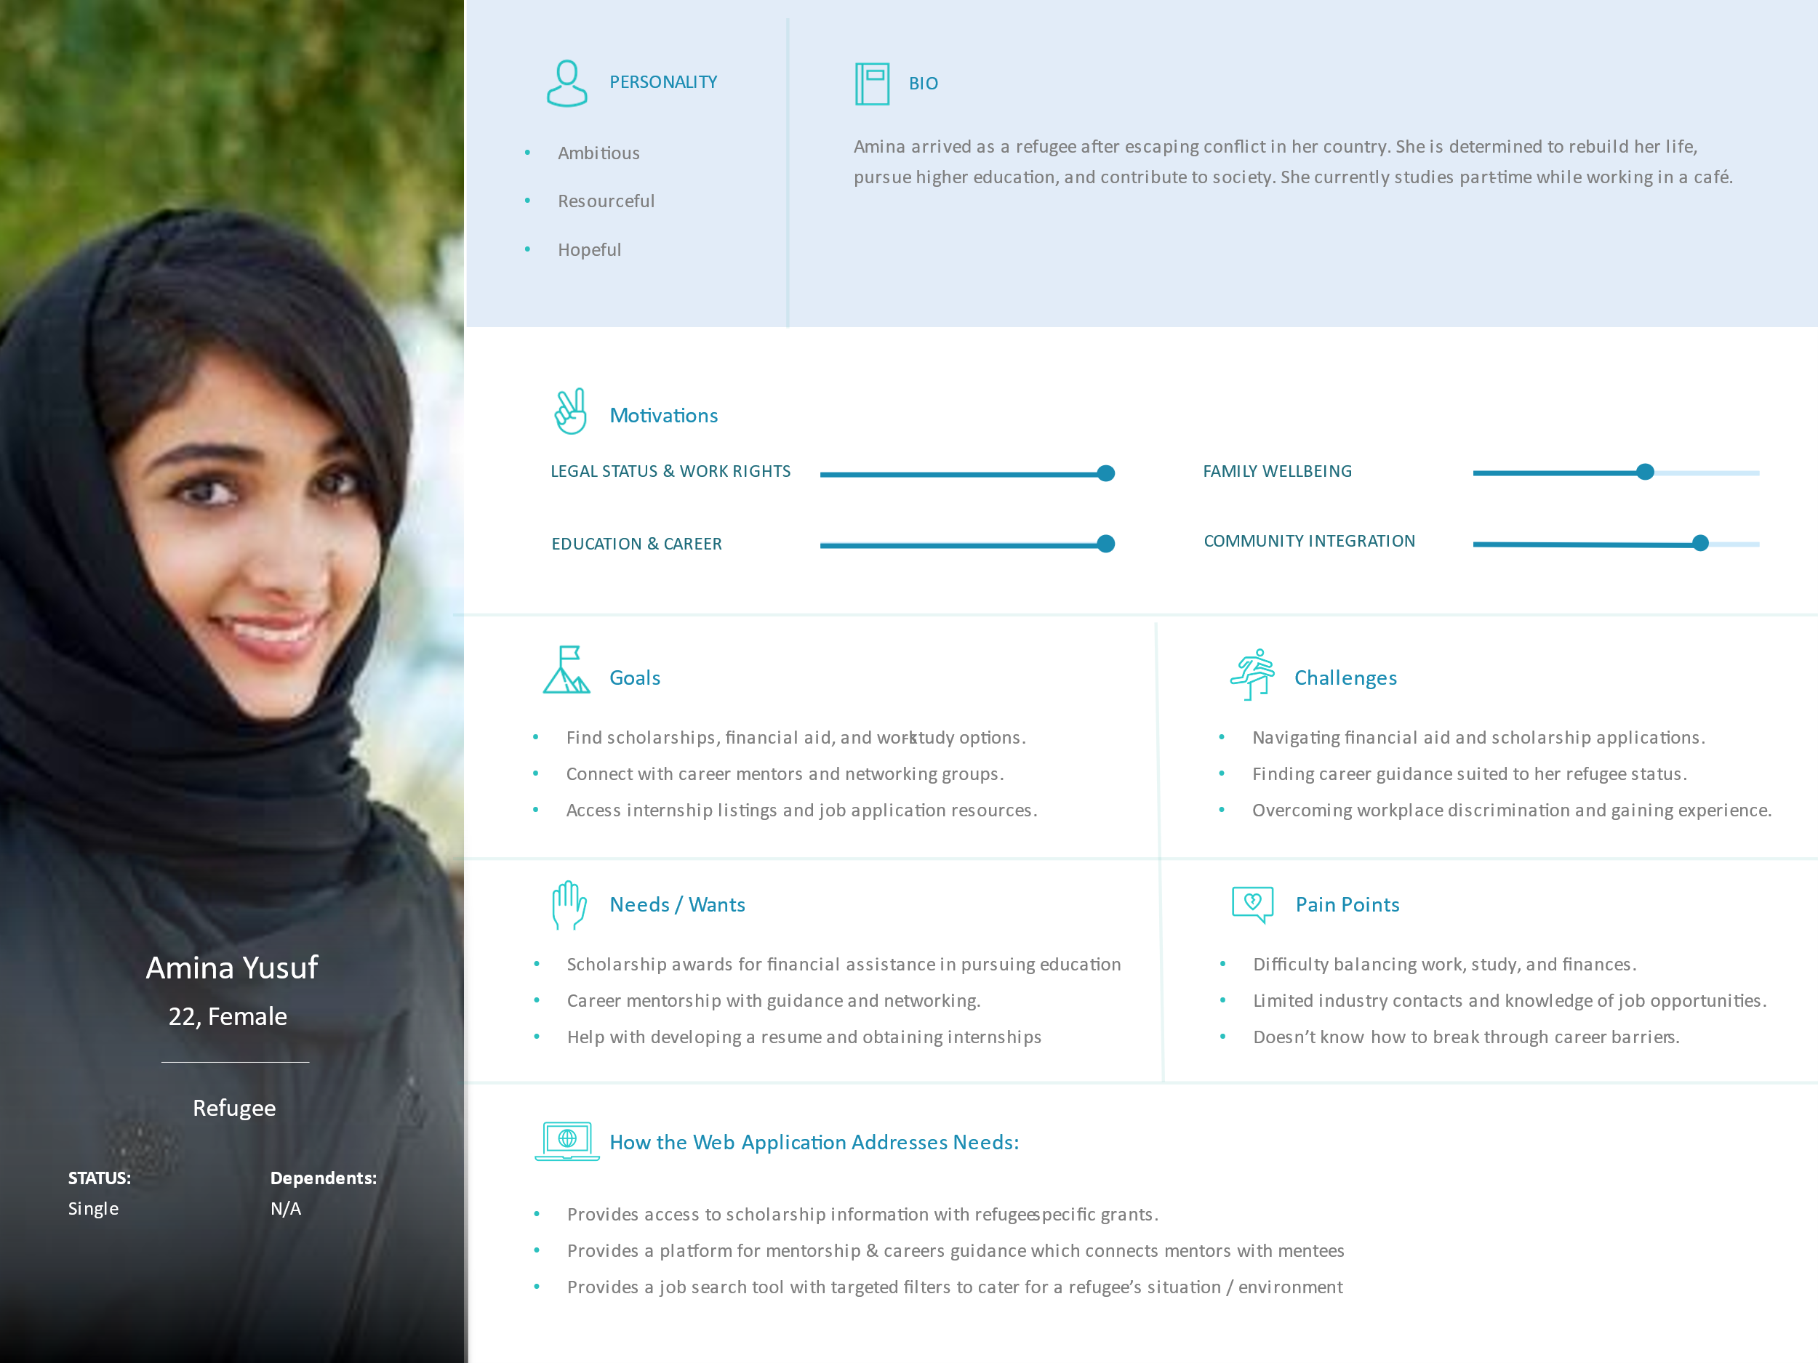

## Section 3: Sitemap

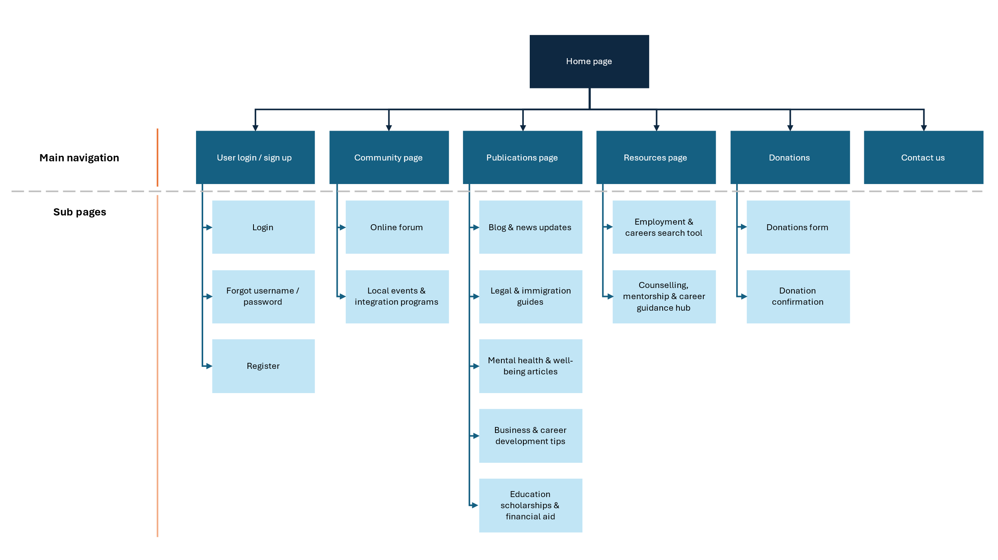

1. User login / sign up: enable login for access to forums and hubs
2. Community page: provides a communication channel to the asylum seeker / refugee communities
3. Publications page: provides relevant and updated information on common topics of interest
4. Resources page: provides the tooling to search for employment and obtain guidance from chosen personnel
5. Donations: enable users to make donations
6. Contact us: provides a central point of contact for further inquiries and support

## Section 4: Wireframes/Low-fidelity prototype

## Declaration: Additional Help

Any tools that you used (including Gen AI or existing code reuse) must be declared here.

**Note**: GenAI is not allowed for coding purposes in any assignment,

However, you may use GenAI for brainstorming and problem solving. You need to declare all such uses here. One row per help used.

|  |  |
| --- | --- |
| Name | Description |
| *Example: ChatGPT for brainstorming ideas* | *I used ChatGPT to brainstorm how to do X because I was feeling stuck with Y problem.* |
|  |  |